King’s COllege  LONDON

OSD PROJECT

**Team Members:**

Yezen Alnafei

Tahmidul Islam

Muhammad Rohman

Stefanos Lianos

Matt Horridge

Alicia

Simeon Arabov

James

Bau

**Contents**

|  |  |
| --- | --- |
| Introduction | 1 |
| Project Management | 2 |
| Class Diagrams | 3 |
| Use Cases | 4 |
| Testing | 5 |
| Conclusion | 6 |

**Introduction**

In this project we …..

**Project Management**

Who did what, why

**Class Diagram**

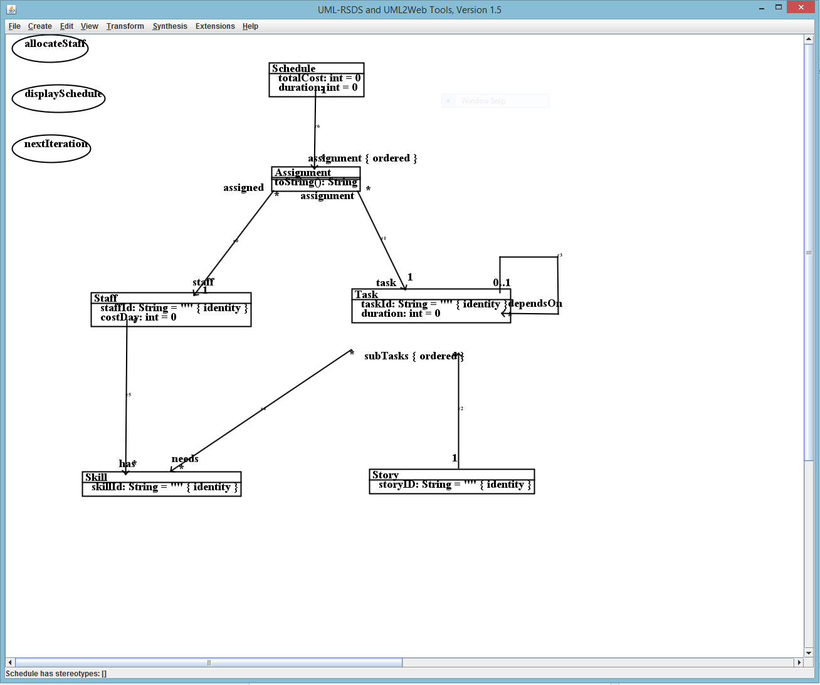

**Use Cases**

Discuss operation specifications

**Testing**

Discuss results of testing…

**Conclusion**